At Home Munchkins Activities!
3rd May 2020
Songs
Parents - you guys sing along too!
He Died Upon the Cross- Colin Buchanan (https://www.youtube.com/watch?v=iT2bHj7n2sc)
Craft
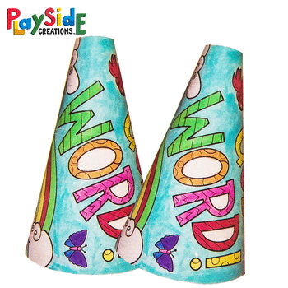
Make and decorate a megaphone! This is a great craft that serves as interactive after it’s made! Decorate a piece of paper and roll it in the shape of a megaphone. The purpose of this craft is to point the kids towards the fact that we want to be telling other people the good news of Jesus.
Some ideas of what words to include on the decorations include: “Jesus”, “Good News” or “Gospel” if your child is familiar with that term.

