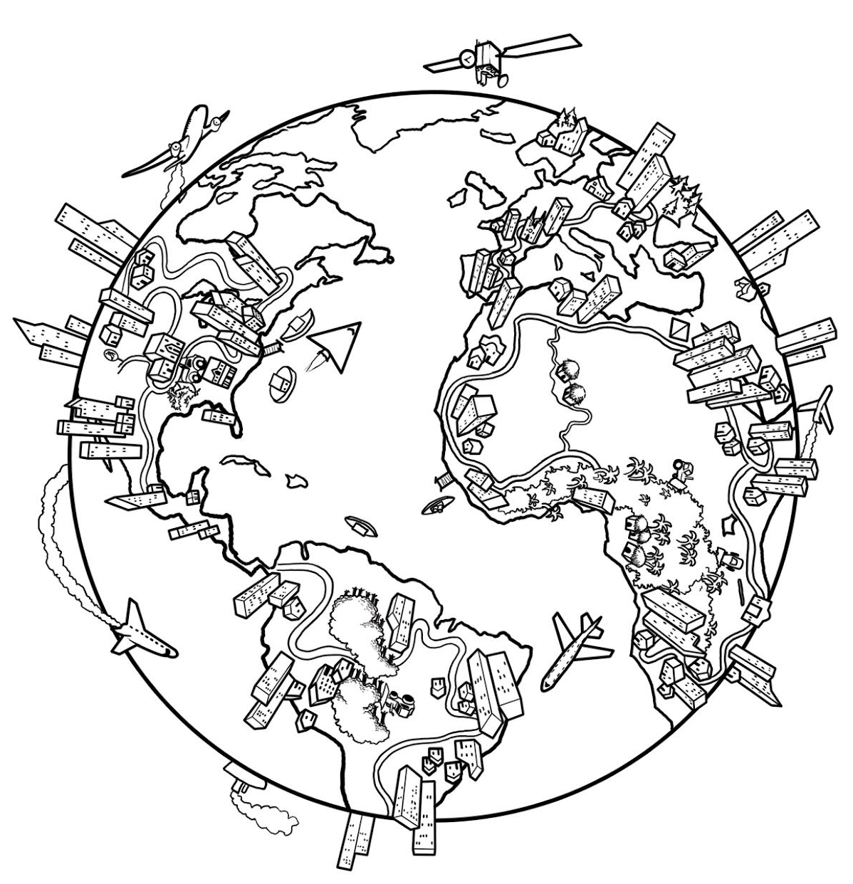
But the Holy Spirit will come to you. Then you will receive power. You will be my witnesses—in Jerusalem, in all of Judea, in Samaria, and in every part of the world. Acts 1:8

